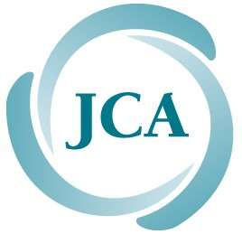

Still Driving?

Do you ever think about the time when you will no longer drive?
Let’s Talk!

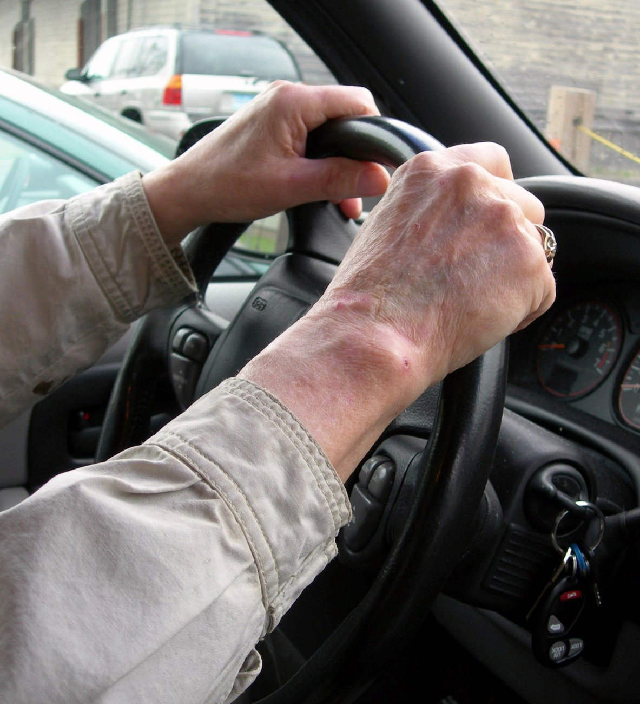
Join a FREE support group with your peers to talk about driving and changes that take place with aging that may affect your ability to drive safely.

How does it work? Small groups of older adults meet once a week for three weeks. Each 90-minute session is led by a facilitator, and at the 2nd meeting, a Certified Mobility Specialist from Connect-A-Ride
will share information about transportation options that can help you stay mobile when you stop driving.
SIGN UP NOW FOR THE NEXT THREE-SESSION SUPPORT GROUP:

a.m. to 12:30 p.m. – November 15, 22 & 29 Jewish Community Center of Greater Washington
6125 Montrose Road, Rockville, MD

To register, or for more information, call CONNECT-A-RIDE at

301.738.3252
Office hours: Mon. – Fri., 9 a.m. to 5 p.m. (Leave a message at other times)

Or email: ConnectARide@AccessJCA.org

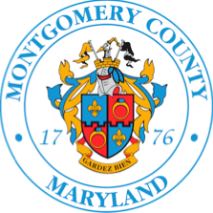
Jewish Council
for the Aging
®

www.
A
ccess
JCA
.org

